Linking Clinotypes to Phenotypes and Genotypes from Laboratory Test Results in Comprehensive Physical Exams

Thanh Nguyen¹, Tongbin Zhang^{2,3}, Geoffrey Fox⁴, Sisi Zeng²⁺, Ni Cao²⁺, Chuandi Pan^{2,3,*}, Jake Y. Chen^{1,*}

¹Informatics Institute, School of Medicine, the University of Alabama at Birmingham, Birmingham, Alabama, United States
²School of First Clinical Medical Sciences - School of Information and Engineering, Wenzhou Medical University, Zhejiang, China
³Department of Computer Technology and Information Management, the First Affiliated Hospital of Wenzhou Medical University, Zhejiang, China
⁴School of Informatics, Computing, and Engineering, Indiana University, Bloomington, Indiana, United States

+ The authors contributing equally to the work

* corresponding email: jakechen@uab.edu, pcd_wzmu@163.com

Abstract
Objective: In this work, we aimed to demonstrate how to utilize the lab test results and other clinical information to support precision medicine research and clinical decisions on complex diseases, with the support of electronic medical record facilities.
Materials and Methods: We defined “clinotypes” as clinical information that could be observed and measured objectively using biomedical instruments. From well-known ‘omic’ problem definitions, we defined problems using clinotype information, including stratifying patients - identifying interested sub cohorts for future studies, mining significant associations between clinotypes and specific phenotypes-diseases, and discovering potential linkages between clinotype and genomic information. We solved these problems by integrating public omic databases and applying advanced machine learning and visual analytic techniques on two-year health exam records from a large population of healthy southern Chinese individuals (size n=91,354). When developing the solution, we carefully addressed the missing information, imbalance and non-uniformed data annotation issues.
Results: We organized the techniques and solutions to address the problems and issues above into CPA framework (Clinotype Prediction and Association-finding). At the data preprocessing step, we handled the missing value issue with predicted accuracy of 0.760. We curated 12,635 clinotype-gene associations. We found 147 Associations between 147 chronic diseases-phenotype and clinotypes, which improved the disease predictive performance to AUC (average) of 0.967. We mined 182 significant clinotype-clinotype associations among 69 clinotypes.
Discussions and conclusions: Our results showed strong potential connectivity between the omics information and the clinical lab test information. The results further emphasized the needs to utilize and integrate the clinical information, especially the lab test results, in future PheWas and omic studies. Furthermore, it showed that the clinotype information could initiate an alternative research direction and serve as an independent field of data to support the well-known ‘phenome’ and ‘genome’ researches.

Keyword: clinotype, lab test result, electronic medical record, machine learning

Background
As electronic health records (EHR) has been increasingly supporting biomedical and healthcare service research, utilizing the clinical information, especially the clinical test information, to strengthen precision medicine is still an open challenge [1]. Here, we have seen many EHR applications in improving precision medicine and quality of care, including: identifying disease risk factors [2], molecular biomarkers [3]; identifying high-risk/special-treatment cohorts [4, 5]; identifying the comorbidities[6, 7]; detecting drug adverse events and side effects [8]; repurposing drugs [9]; and predicting early hospitalizations [10]. However, it is still unclear to what extent the findings associate to specific clinical test results, which are among the most practical information for the care providers [11]. In addition, whether these associations imply that the test results are risk factors or just the reflection of the phenotype is still ambiguous. For example, the monocyte count, which is a popular blood test, is the result of the inflammatory response in chronic obstructive pulmonary disease and could be as a risk factor leading to cardiovascular diseases [12].
In the other hands, electronic medical data systems and analytical methods, which are the essential facilities to tackle the challenge above, have been gradually matured. At the data system component, elements in EHR data, including the medical test information, unified medical language system [13], and data integration [14] have been standardized [15-17] and well-supported to EHR extraction and refinement. In addition, from natural language processing tools [18], manual curation and crowd-sourcing efforts, there have been many data sources [19-21] potentially allows linking the clinical test results, the phenotypic/clinical outcomes, and genotype information. At the analytical component, custom statistical data mining and machine learning techniques have been applied to EHR data to cope with challenges in understanding biomedical and healthcare big data. To determine disease risks, one can use a popular statistical analysis technique—disproportionality analysis [22]. To predict patient survival and track disease progression using clinical biomarkers [23, 24], one can perform temporal data analysis such as regression in time series analysis [25] and Cox regression model [26]. To perform classifications based on multivariate models [27], one can build statistical learning models such as decision tree [28], artificial neural network [29], hidden Markov model, and support vector machine [30, 31]. In addition, set-based statistical analysis methods, such as chi-square and Fisher’s exact test are also useful in evaluating the significance of the findings [32]. There have been several examples of informatics systems allowing utilization of medical test and other clinical information, such as eMERGE [33] and I2B2 [34], where the integration of test results and genotype information would help in specifying the cohorts of interest and customized algorithm are developed for disease-specific problems.
Given these better facilities, why EHR and its rich clinical test information has not been able to play a more active role in precision medicine? Among many limitations, [35] highlights the data quality issues: “interoperability, poor quality, and accuracy of the collected information”. In other words, EHR data have has three specific challenging issues to address. First, EHR data contains missing values [36] because of human error or non-response subjects [37]. Second, EHR data is naturally imbalanced: class imbalance, for example, the small percentage of ‘abnormality’ events, and patient demographic imbalance. Third, EHR data lacks thorough and uniform annotation. Usually, the annotation needs to be made patient-specific.
This work is a pioneering framework in better-utilizing EHR, especially its rich clinical test result, to enhance precision medicine, defining new problems and providing solutions in biomedicine involving these data. We proposed the concept “clinotype” in response to the call for clinical information modeling, especially for querying and analytics over clinical content and decision support over clinical content [38]. We define “clinotypes” as clinical information, excluding the treatment, that can be observed and measured objectively using biomedical instruments. Most of the clinotypes are hospital lab tests. However, we argue that the “clinotype” concept and the “hospital lab test” are not entirely the same due to two reasons. First, with the development of mobile devices, the patients can self-perform some measurements outside the hospital laboratory; therefore, the term “hospital lab test” may not be well-applied in this case. Second, hospital lab tests include drug testing (treatment-related); therefore, this type of lab test is excluded from “clinotype” definition. In addition, different from “phenotypes” commonly used in biomedicine, which is associated to disease morphology developed by healthcare professionals [39], clinotypes are qualitative or quantitative measurements that are neutral to expert judgment. We tackled the data quality issues by both data quality control and machine learning support. We defined three board problems of ‘clinotype’ data analytics: clinotype-clinotype association discovery, clinotype-phenotype association discovery and clinotype-genotype relationship discovery. We named the framework CPA (Clinotype Prediction and Association-finding). The dataset used in this study, provided by the 1st affiliated hospital – Wenzhou Medical University – China (acronym: 1AH), contains values of totally 400 clinotypes, with no specification on interested cohorts or diseases. This dataset was collected between 2012 and 2014 from 91,354 patients, which well-represents the Southern Chinese population, mostly from south of Fujian province and the entire Zhejiang province with more than 20 million civilians.

Results
In this work, we use the following acronyms:
- SVLR: support vector linear regression
- PPV: positive predictive value
- NPV: negative predictive value
- ACC: accuracy
- AUC: area under the receiver-operating characteristic curve
CPA is an integrative machine learning framework, including data preprocessing and clinotype analysis as presented in figure 1. From the original data (P0), which consist of 9,283,306 clinotype results from 91,354 patients and 400 clinotypes, we filtered insignificant clinotypes and patients and normalized the data. In data preprocessing, due to technical limitations in Chinese natural language processing, we were unable to include the non-numerical clinotype results. After preprocessing, we used P2 data subset and available diagnosis information to solve the clinotypes problem: discovering clinotype-phenotype (disease) associations and stratifying the patients' clinotype data for interested cohort identification. We curated the existing 'omic' data sources for clinotype-genotype information. More technical details and metrics of evaluation could be found in the method sections.

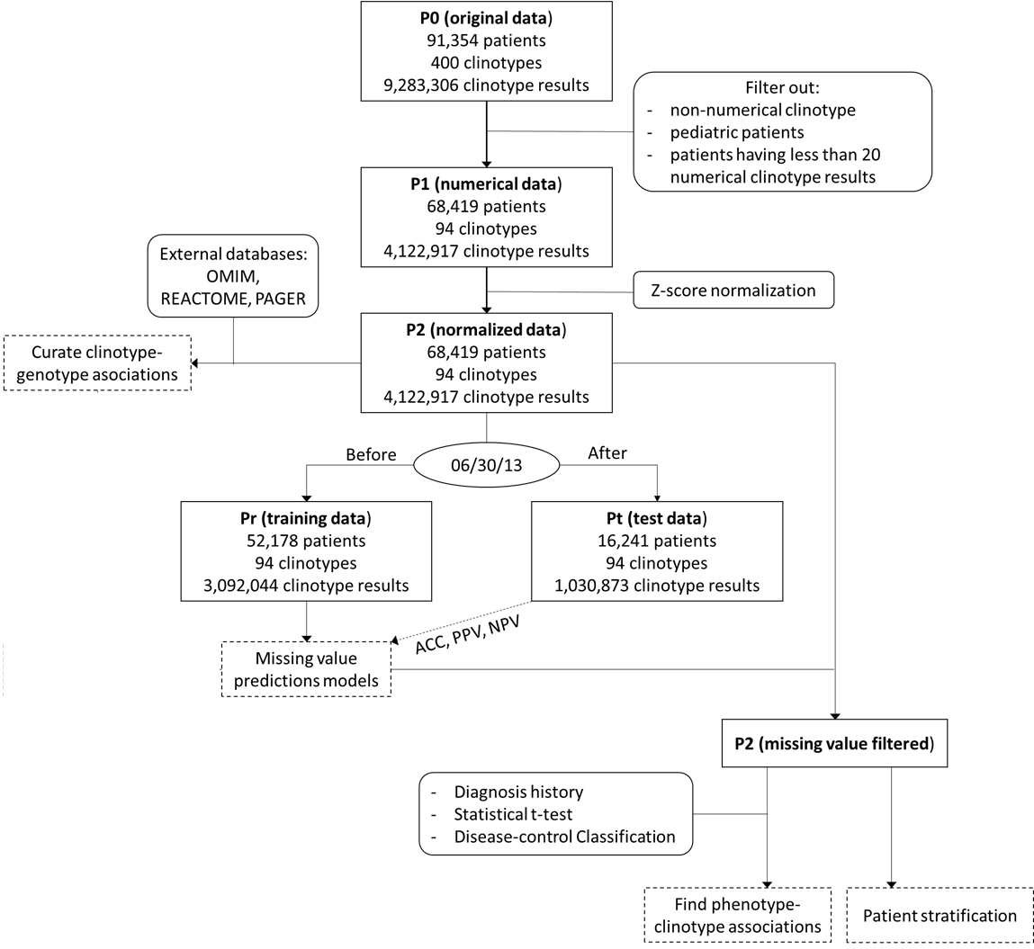
- Flowchart for CPA framework. The rectangle boxes represent clinotype data subsets from P0 to Pr/Pt. The dash rectangle boxes represent clinotype problems and main results. The rounded rectangle boxes represent external (non-clinotype) data and techniques help solving the clinotype problems.

Robust missing value prediction models
In tackling missing value issue, the prediction performance of SVLR is desirable for predicting values of a number of numerical clinotypes. Overall, the weighted prediction accuracy for all measurement is 0.760, the weighted average PPV is 0.488, and the weighted average NPV is 0.829. This performance is significantly higher than the random prediction, in which, due to the metric defined in Table 3 in the method sections, the expected random ACC/PPV/NPV would be 0.33. Supplementary Table 1 shows all prediction performance metrics of all clinotypes. There are three scenarios for the performance of SVLR on predicting missing clinotypes. First, Blood Platelet Hematocrit, Average Erythrocyte Volume, and Lymph Absolute Value show both high (above 0.7) PPV and accuracy. Second, Albumin, RBC Volume Distributed SD Value and Neutrophils Absolute value show average PPV (from 0.5 to 0.7) and high accuracy. Third, Lipid-related measurements, such as LDL-Cholesterol, Apolipoprotein B and Triglycerides achieve moderate PPV but moderate or low accuracy (below 0.7), except LDL cholesterol. Most of the clinotype NPVs are high, except for lipid-related measurements
The SVLR may not be very accurate to model clinotypes for old people. In Figure 2, accuracy, PPV and NPV of models trained by young-age and middle-age groups are higher than the ones trained using old groups. Furthermore, the average NPV and accuracy trained by old-age groups are lower than the average NPV and accuracy using the entire dataset. As Supplementary Table 3 f-g show, old groups have significantly less reporTable predicted clinotypes compare to other groups.

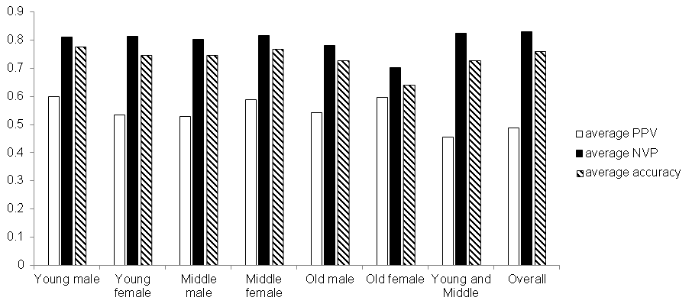
- Performance of SVLR models for predicting missing values: Average ACC, PPV and NPV comparison between different groups of patients (defined in Table 2).

The significant disease-phenotype-clinotype associations could potentially improve disease identification
Here, we focused on the phenotype-clinotype associations of five popular chronic diseases: chronic gastritis, coronary, cataract, hyperlipidemia, and diabetes. We found 147 significant phenotype-clinotype associations (supplemental Table 2). We demonstrated the top 10 significant clinotype-phenotype associations, sorted by p-value, in Table 1. Figure 3 shows that the classification models built upon these associations (acronym: ASS models) are completely superior to the models built without using these associations (non-association, acronym: NON models). Briefly, the ASS models only use the clinotypes that have strong associations to the diseases; while the NON models do not use these clinotypes. The details on constructing these models, from finding clinotype-phenotype associations to classification algorithms (random forest) could be found in the method section. In all diseases, the ASS models achieve higher AUC and PPV. By average, the ASS models AUC of 0.967 and PPV of 0.923; meanwhile, the NON models only achieve AUC of 0.942 and PPV of 0.886.
Clinotype | Disease-phenotype | p-value
Blood Crystallization | Diabetes | 3.36x10⁻¹⁸
Blood Crystallization | Coronary | 1.48x10⁻¹⁷
Rheumatoid Factor | Hypertension | 1.78x10⁻¹⁶
Blood Crystallization | Hyperlipidemia | 1.47x10⁻¹³
Rheumatoid Factor | Chronic gastritis | 4.77x10⁻¹²
Glucose | Diabetes | 1.71x10⁻¹¹
Crystallization | Cataract | 4.22x10⁻¹¹
Rheumatoid Factor | Hyperlipidemia | 6.47x10⁻⁹
Blood Platelet | Hyperlipidemia | 6.24x10⁻⁷
Triglycerides | Hyperlipidemia | 6.61x10⁻⁷

- Top 10 significant clinotype-phenotype association found in P2 dataset

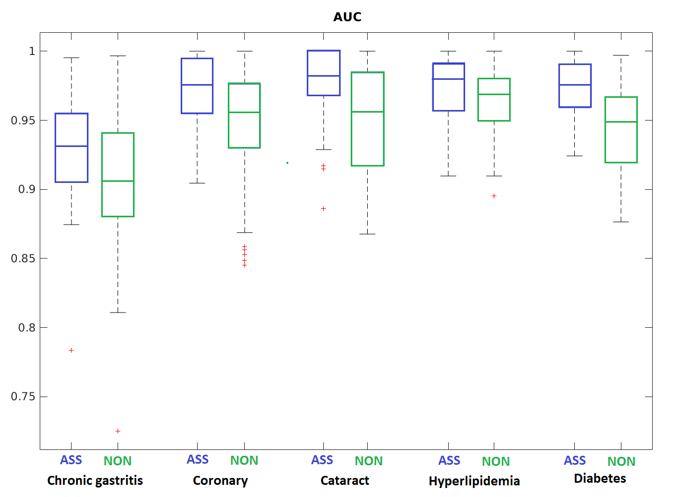
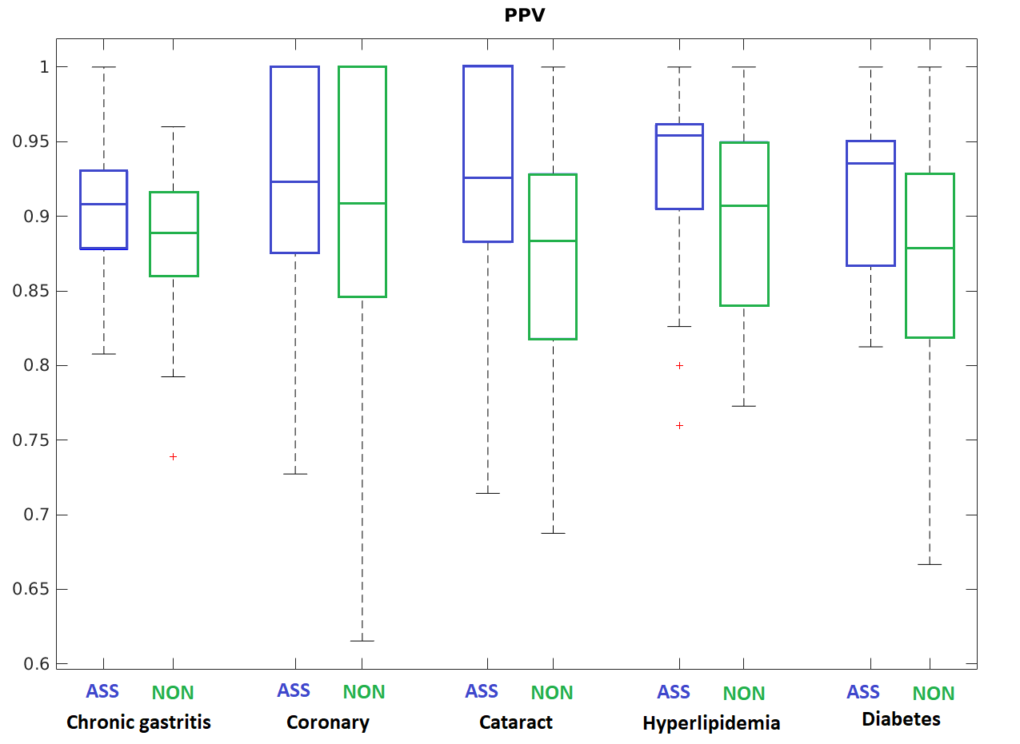
- AUC/PPV Comparison between two types of the disease-specific classification model: using (ASS) and not using (NON) only disease-phenotype-clinotype association.

Cohort identified by stratification of patients’ clinotype reveals potential chronic comorbidities
For 5 subcohorts identified by Plotviz clustering, the ANOVA tests return 67 significant clinotypes (Supplementary Table 3) which could be used to annotate each cluster. Information for selecting the number of clusters could be found in supplemental material. Interestingly, the unbias and domain-knowledge free clustering method (Plotviz) results in patients subgroups who have potentially similar disease phenotypes. The top 5 significant clinotypes are Blood Platelet Distributed Width (p-value 1.79×10⁻¹⁶⁹), Postprandial 2h Blood Sugar (p-value 3.58×10⁻¹³³), Glucose (p-value 9.69×10⁻¹⁰⁴), Saccharification Blood Protein (p-value 6.01×10⁻⁷³) and Crystallization (p-value 7.92×10⁻⁴⁹). These top 5 clinotypes annotate two clusters (Figure 5). Blood platelet Distributed Width and Crystallization is higher cluster 3 containing 101 patients. Postprandial 2h Blood sugar, Glucose and Saccharification Blood-red Protein specify cluster 1 containing 843 patients. Supplemental Table 4 summarizes the disease-phenotype annotation for each cluster. These annotations could be visualized using with Plotviz (http://salsahpc.indiana.edu/plotviz/) visualization and data files in Supplemental File 7.

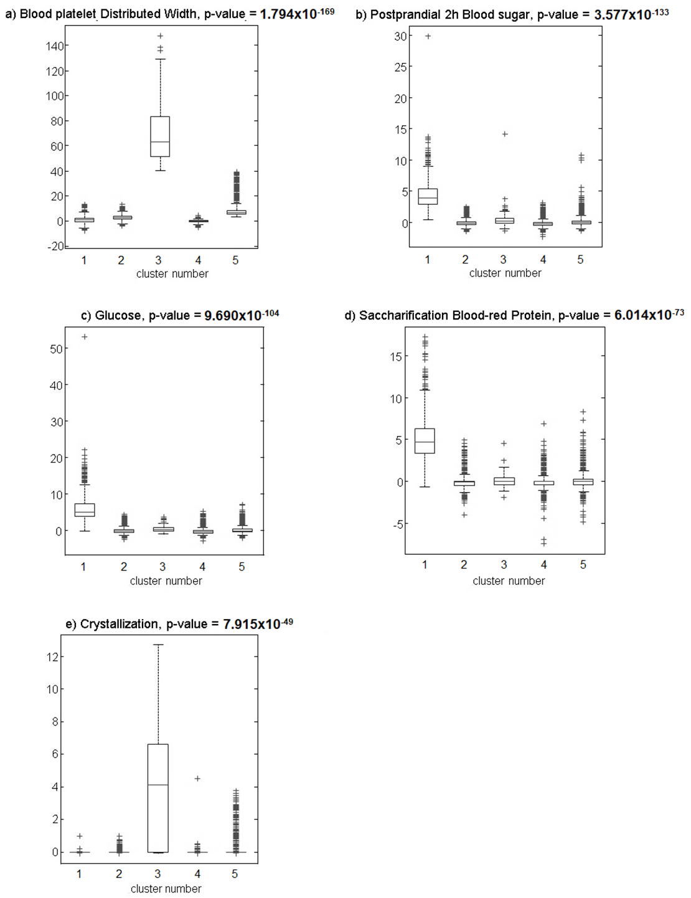
- Top 5 clinotypes annotating identified subcohorts. x axis stands for the cluster index. y axis stands for the normalized clinotype values
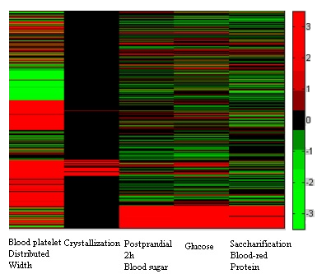
- Clustering heatmap with top 5 measurements: Patients are represented by rows. The order of columns is Blood platelet Distributed Width, Crystallization, Postprandial 2h Blood sugar, Glucose, and Saccharification Blood-red Protein

Discussions
In this work, CPA’s machine learning technique could successfully predict the missing health clinotype values. Accurate missing-value prediction provides qualified information for supporting diagnosis and a better understanding of the patient at an individual level. In addition, Plotviz clustering technique could reveal patient subgroups who potentially share similar health issues. Validation via curation shows potential explanation about significant clinotype-clinotype associations at the gene level. This result could be used to suggest new biological research topic about the clinotype-genotype associations.
We also want to clarify the difference of “clinical modeling” concept, which our CPA framework aims for, with the “clinical information models” (CIM) defined by Moreno-Conde’s group [40]. In [40], CIM is a board concept for structural and semantic artifacts providing multiple functionalities: organizing, storing, querying, visualizing, exchanging and analyzing data. In the CPA framework, missing value prediction and clinotype-clinotype association discovery could be called analyzing data functionalities. In addition, the results from patient clustering and linking clinotypes to genomic databases could certainly lead to new clinical trials and research. Therefore, CPA could extend the CIM concept by adding the recommendation functionality, which could be very helpful for doctor and research users.

There are three main limitations of this research work. The first limitation is that the linear prediction models do not work well with patients from old-age groups. Therefore, the nonlinear methods are better-recommended to learn the clinotype-clinotypes associations the follow-up analysis from the old-age-group data. The second limitation is constructing the semantic structure among health clinotype names. Thus, we could not use standard annotation code for diseases, symptoms and other phenotypes, such as ICD10 and MeSH term to acquire better curation as in [41].
In addition, to complete the triangle among clinotype, phenotype and genotype, the CPA framework should include the following problems. First, mining clinotype-clinotype association would complete the clinotype-clinotype edge, which has not been addressed. Machine learning techniques could be reapplied in this problem. Second, linking the clinotype-clinotype and clinotype-genotype associations to the gene level would provide insights explaining the associations above. Here, integrating PheWas with better clinotype-phenotype association (from curation and natural language processing) would be a promising solution. We would solve these problems in some future work.
In addition, PPV leaves two issues for open discussion in this work. First, the weak anti-correlation between prediction accuracy and PPV leaves an issue in sampling the training set. It is expected that when we use totally random balance sampling in the training set, the distribution of predicted labels in the test set may contain less ‘normal’ label and may increase PPV. However, ‘normal’ is the major label; therefore, increasing PPV may decrease accuracy. We do not have a clear answer whether or not more advanced data sampling approaches in[42] could be a better solution due to the missing value. Second, although the average PPV achieved in this work is moderate (PPV), we argue that it is a reporTable outcome. In this study, the ‘positive’ class stands for abnormal measurement value (either high or low), which is often the minor class in health data. In addition, our definition for true positive (see method section of setup metrics for prediction performance) only allows the predicted label and the true label as either ‘high’ or ‘low’. In other words, if the predicted is ‘low’ but the true label is ‘high’ and vice versa, we still consider this case as false positive although both the predicted label and the true label are not ‘normal’. With this definition, the expected random PPV is 0.33, much less than the average PPV we achieved. Our plausible results in clinotype-clinotype association discovery and patient clustering, which directly use clinotype missing value prediction, show that the discovery is still solid with the PPV above. However, we believe that the discovery could be improved if we apply other techniques with higher PPV.

Conclusions
By CPA framework, we showed how utilizing clinical test results information (clinotype) could further support precision medicine. The proposed problems and solutions with clinotypes demonstrate that clinotype could potentially be an independent area but associating with the well-known genotype-phenotype association studies. Machine learning techniques play a key role in this pioneering work. It could lay out the general ideas from which the future techniques could improve the solution for each problem proposed in this work.

Materials and Methods

Acquire and preprocess data
We acquired, preprocessed and organized the dataset according to the workflow in Figure 1 by 3 steps, which creates 5 data subsets: P0, P1, P2, Pr and Pt. P0 stands for the original dataset after removing patients’ identifiable information. P1 stands for subsets of data related to numerical clinotype. P2 stands for the normalized dataset from P1. Pr and Pt stand for the training set and the test set correspondingly in machine learning. The data preprocessing would tackle the non-uniform annotation issues and support machine learning as follow.
The original P0 subset, acquired directly from the health checkup (which is an independent department at 1AH), contains records on 400 health clinotype values of 91,354 patients between September 2011 and May 2014. Among 91,354 patients, 712 patients (0.7%) are under 18 years old. More information about the selected cohort could be found in Table 1. Since this work focuses on health clinotype, we manually translated the clinotype names from Chinese to English. To improve the quality of our translation, we queried our translated English name in popular medical terminology resources: MedLinePlus (http://www.nlm.nih.gov/medlineplus/), Lab Tests Online (https://labtestsonline.org/), PubMed (http://www.ncbi.nlm.nih.gov/pubmed/ for title/abstract) and adjusted our translation according to the closest matched terms in these resources. Importantly, for each personal clinotype result in P0, the 1AH provided the normal reference ranges, which referred to Chinese medical guidance and was the standard requirement at any 1AH medical record. The reference ranges are subjected to individuals. For example, the Hematocrit test in P0 has two reference ranges: 35-45% for female individuals and 40-50% for male individuals. The normal reference ranges allow annotating all clinotype results as ‘high’, ‘normal’ and ‘low’. Therefore, in this work, we tackled the annotation issue by applying the domain knowledge and data standard from the care provider.
The P1 subset results from P0 by filtering out low-confidence patient and clinotype information. Among 400 clinotypes, 97 clinotypes are numerical. In this work, due to the technical limitation in Chinese natural language processing, we did not include the non-numerical test result, which often include free text. Three clinotypes: Yeast Culture, Creatinine (Enzymatic) and Thyroid Globulin Antibody (ECLIA) are rare (taken by less than 1000 patients, or 1% of the population size) and excluded from the study to reduce the noisy effect in statistical machine learning methods. Thus, 94 clinotypes remained for further preprocessing and analysis. We also removed patients having no numerical clinotypes and 213 pediatric patients (< 0.1%) due to low count. P1 contains 4,122,917 patients’ health clinotypes entries from 68,419 patients.
The P2 subset results from P1 by normalizing clinotype results with the z-score formula
$$\tilde{x_{i,n}}=\frac{x_{i,n}-\overline{x_{i}}}{σ_{i}} (1)$$
in which i is the clinotype index, n is the patient index, $\overline{x_{i}}$ is the mean of clinotype i ,$σ_{i}$ is the standard deviation of clinotype i and $\tilde{x_{i,n}}$ is the normalized value of patient n on clinotype i. The mean and standard deviation was calculated only from the training set. We chose z-score normalization because it could remove all of the clinotype biases and variances in machine learning. In addition, z-score normalization is a linear method, which is suiTable for interpreting and validating the results from linear regression later. We scaled the normal range for each individual clinotype result using the same mean and standard deviation at (1).
We setup the training subset Pr and subset Pt for downstream machine learning analysis and validation. We selected the date June 30 2013 to separate the dataset. This date divides the P2 set into a training set and test set following conventional ratio 3:1 (Figure 1). Pt and Pr allow tackling the missing value issues using machine learning, which we would describe later. For missing values existing in Pt and Pr, we replaced them with the corresponding predicted values computed from the missing value models. The P2, Pt and Pr subsets allow defining and solving the clinotype – related problems as shown in Figure 1 pipeline.
In addition to the P0 dataset, the outpatient department at 1AH provided the diagnostic history, identified by Chinese ICD version 10. More information about disease-specific cohort could be found in supplemental Table 5.

Age group | Gender | No. Patient (%)
Young (18-39)

 | Male | 14,594 (21.33)
 | Female | 12,596 (18.41)
Middle (40-59)

 | Male | 18,717 (27.36)
 | Female | 14,137 (20.66)
Old (60 and above)

 | Male | 5,207 (7.61)
 | Female | 3,168 (4.63)
- Statistics about the demographic information in the selected cohort.

Handle the missing value and data imbalance

Technical solution
Built upon machine learning techniques, the CPA framework handled the missing value issue and partially data imbalance issue in one step. We select the support vector linear regression (SVLR) to build models predicting the missing value. Compared to other techniques in handling missing data [43, 44], we preferred SVLR because of not only its higher sparsity [45, 46] but also its models could be directly applied to discover clinotype-clinotype associations. For each clinotype y, the SVLR estimate the missing value using the linear model $\tilde{y_{n}}=w^{T}x_{n}+b$ if the clinotype value of patient n is missing. Here, $\tilde{y_{n}}$ denotes the estimation for missing value, x_{n} is the vector of other (non-missing) clinotype value for patient n, and w denotes the coefficient for these non-missing clinotypes. SVLR uses the non-missing y in Pr subset to train the model. Briefly, the SVLR setup the solution minimizing:
$$\frac{1}{2}\left|w\right|+C\sum_{n}^{N}{ξ_{n}}$$
subject to $\left\{\begin{aligned}w^{T}x_{n}+b≥y_{n}-ε-ξ_{n} \\ w^{T}x_{n}+b≤y_{n}+ε+ξ_{n}\end{aligned}\right. (2)$
and $ξ_{n}≥0 ∀n$
Here, y_{n} denotes the non-missing value for y in training, ε ≥ 0 is the ‘tolerance’, or expected error between the predicted and the real y_{n} in regression, and $ξ_{n}$ is the slack variable as defined in [45, 46]. Parameter C and ε decide the trade-off between the smoothness of regression function and how tolerance the predicted clinotype value could deviate from the true clinotype value. We decided to use C = 1 and ε = 0.001 after testing multiple choices of C = 0.001, 0.01, 0.1, 1, 100, 1000 and multiple choices of ε = 0.001, ε = 0.01, ε = 0.1 ε = 1. We used ILOG CPLEX Optimizer [47] to solve the problem (2).
To partially tackle the data imbalance issue, in implementation, we applied the under-resampling method in [48] to select the balanced subset in the training phase. By balancing, we mean for each predicted-target clinotype y in (2), the ratio among ‘normal’, ‘high’ and ‘low’ y_{n} selected in training is relatively 1:1:1. For each clinotype prediction, we ran resampling, learning and predicting 50 times and reported the average for coefficients and predicted value.

Performance metric and validation
We used the models (2) built upon Pr subset to estimate the non-missing clinotype values in Pt set. Since each non-missing clinotype value has a reference range, the real and estimated clinotype value could be annotated as either ‘high’, ‘normal’ or ‘low’. Therefore, we have 9 possible outcomes as shown in Table 2.
 |  | Estimated value annotation
 |  | High | Normal | Low
Real value annotation | High | TP | FN | FP
 | Normal | FP | TN | FP
 | Low | FP | FN | TP
- Confusion matrix between the estimated and real clinotype value annotation. TP: true positive, TN: true negative, FP: false positive, FN: false negative
With the emphasize on predicting abnormality, we had the accuracy (ACC) and positive predictive value (PPV) metrics as
$$ACC=\frac{TP+TN}{TP+TN+FP+FN}$$
$$PPV=\frac{TP}{TP+FP} (3)$$

Curate the clinotype - genotype association
Since we did not have genetic test information among the study cohort, we used public databases PAGER [49, 50] and REACTOME [51, 52] (pathway and metabolism only) to find genes associated with the clinotypes. PAGER is a geneset database, which integrates the most popular geneset-level databases known today (including MsigDB) and collection of phenotype-related genes from popular manual curated databases, including OMIM [53, 54], MSigDB and GeneSigDB [55]. REACTOME is one of the most well-known curated biological pathway databases known today. We removed non-biological words in each clinotype name, such as absolute value, percentage, ratio, volume, etc. and convert all names to singular form before querying. For example, with clinotypes “Basophils Percentage” and “Monocytes Absolute value”, we queried “Basophil” and “Monocyte”. After acquiring the clinotype’s related gene set, we used DAVID Gene ID conversion tool [56, 57] to map the names retrieved from REACTOME and PAGER to UniProt ID to remove potential alias names and ensure that the genes found were reviewed. After querying and filtering, we obtained 12,635 connections between 6145 genes and only 61 clinotypes, as showed in supplemental Table 6.

Find disease-phenotype and clinotype associations

Technical solution
Using the diagnostic information for the cohort covered in P1 subset, we found the disease-phenotype and clinotype associations with the help of student t-test [58] as follow. In P1, we select patients having less than 5% abnormal clinotype values and no diagnostic history into the control set. For each disease, we use the ICD10 diagnostic code to select the ‘disease’ set. Comparing between the disease and control sets with t-test, we computed the p-value for each clinotype. The clinotypes having significant p-value (less than 0.05) was considered to have significant associations with the underlying disease.

Performance metric and validation
To validate these associations, we compared the disease-versus-control classification performance using two types of model. For the first type of model, noted as ASS (abbreviation of association), we only use the disease’s associated tests as features for classification. For the second type of model, noted as NON (abbreviation of non-association), we only used the non-associated tests as features for classification. We trained the classification models using the Pr set and measure the performance on the Pt set, as shown in the above section. We expect that the classification metrics: area under the curve (AUC) and accuracy [59] of the ASS models should be higher than the ones in the NON model. For training classification models, we applied Random Forest [60] implemented in Weka version 3.8 [61], which was significantly successful in Google’s and Mt. Sinai’s DeepPatient [62].

Identify subcohorts of interest by patient stratification
We used the Plotviz tool [63, 64], built upon the high-performance computing platform at Indiana University, to cluster the P2 subset patients. Deterministic Annealing Pairwise Clustering (DAPWC) algorithm [65], which focuses on highlighting the datapoint difference in high dimensional data, Plotviz significantly reduced the computational time, performed dimensionality reduction and visualize the results in 3D. To determine the number of cluster parameters (k) in Plotviz, we applied Silhouette index [66] (Si) to select the best number of clusters. Si closed to 1 implies appropriate clustering structure; meanwhile, Si closed to -1 implies inappropriate clustering structure, including too few and too many clusters. From multiple experiments, we choose k = 5 (Si = 0.793).
We proposed two option to annotate the clusters. First, we found the significant clinotypes expressing in each cluster by the ANOVA test. Clinotypes returning significant average p-value (less than 0.05) could be used to annotate the clusters. Second, we found which clusters c would over-represent a specific disease D using hypergeometric distribution p-value computed as
$$\sum_{τ=κ}^{min⁡(Κ,η)}{\frac{\left(\frac{Κ!}{\left(Κ-τ\right)!τ!}\right)\left(\frac{(Ν-Κ)!}{\left(η-τ\right)!\left((Ν-Κ)-\left(η-τ\right)\right)!}\right)}{\frac{Ν!}{\left(Ν-η\right)!η!}} (5)}$$
Where $Ν$ (nu) is the number of patients in P2 subset, $Κ (kappa)$ is the number of patients having disease D diagnosis, $η$ is the size of cluster c and $κ$ is the number of patients having disease D in cluster c. The less-than-0.05 p-value implies that cluster c significantly enriches disease D.

Declarations

Ethics approval
The research protocol in this work was approved by Wenzhou Municipal Science and Technology Bureau and The First Affiliated Hospital, Wenzhou Medical University, Wenzhou, Zhejiang, China. This is in accordant to the scientific description in project number ZG2017020, titled “Research and Development of Disease Prevention and Prediction System Based on Cloud Computing and Medical Big Data”. Since the protocol used a large number of individuals’ medical records, it was practically impossible to obtain all participants’ consents. Therefore, the consent requirement was waived. All authors have completed the training required by the Institutional Review Board in this project.

Consent for publication
This work does not include any include identifiable details related to individuals.

Availability of Material
The original datasets are not included in this work. Researchers interested in using the dataset should contact Chuandi Pan or Jake Chen for further details and permission.

Competing interest
The authors declare that this work has no competing interest.

Funding
This work was supported partially by Wenzhou Department of Science and Technology Development (Wenzhou Municipal Science and Technology Bureau), under project number ZG2017020 granted to Chuandi Pan (titled “Research and Development of Disease Prevention and Prediction System Based on Cloud Computing and Medical Big Data”) and the ‘startup budget’ granted to Jake Chen from the University of Alabama at Birmingham.

Authors’ contribution
Thanh Nguyen designed the data structures, preprocessed the data, built the machine learning techniques, designed the validation metric, and primarily prepared the manuscript. Sisi Zeng translated the medical terminologies (including ICD10 diagnosis and clinotype/lab test name) from Chinese to English and curated the clinotype-genotype association. Ni Cao built the database supporting the analysis and executed the clinotype-clinotype association validation. Tongbin Zhang executed the clinotype-phenotype association mining. Geoffrey Fox performed patient stratification using Plotviz technique. Chuandi Pan collected the original data. Jake Chen defined clinotype concepts and problems. All authors participated in preparing the manuscript, including writing, commenting and revising.

Acknowledgment
The authors thank the IT staff from Department of Computer Technology and Information Management, The First Affiliated Hospital of Wenzhou Medical University, Zhejiang, China for helpful guidance in preprocessing the data.

References

1. Manrai AK, Patel CJ, Ioannidis JPA: In the Era of Precision Medicine and Big Data, Who Is Normal? JAMA 2018, 319(19):1981-1982.
2. Liu S, Hou J, Zhang H, Wu Y, Hu M, Zhang L, Xu J, Na R, Jiang H, Ding Q: The Evaluation of the Risk Factors for Non-Muscle Invasive Bladder Cancer (NMIBC) Recurrence after Transurethral Resection (TURBt) in Chinese Population. PloS one 2015, 10(4):e0123617.
3. Goldstein BA, Assimes T, Winkelmayer WC, Hastie T: Detecting clinically meaningful biomarkers with repeated measurements: An illustration with electronic health records. Biometrics 2015.
4. Hillestad R, Bigelow J, Bower A, Girosi F, Meili R, Scoville R, Taylor R: Can electronic medical record systems transform health care? Potential health benefits, savings, and costs. Health Aff (Millwood) 2005, 24(5):1103-1117.
5. Martirosyan L, Arah OA, Haaijer-Ruskamp FM, Braspenning J, Denig P: Methods to identify the target population: implications for prescribing quality indicators. BMC health services research 2010, 10:137.
6. Zeng QT, Goryachev S, Weiss S, Sordo M, Murphy SN, Lazarus R: Extracting principal diagnosis, co-morbidity and smoking status for asthma research: evaluation of a natural language processing system. BMC medical informatics and decision making 2006, 6:30.
7. Roque FS, Jensen PB, Schmock H, Dalgaard M, Andreatta M, Hansen T, Soeby K, Bredkjaer S, Juul A, Werge T et al: Using electronic patient records to discover disease correlations and stratify patient cohorts. PLoS computational biology 2011, 7(8):e1002141.
8. Harpaz R, Chase HS, Friedman C: Mining multi-item drug adverse effect associations in spontaneous reporting systems. BMC bioinformatics 2010, 11 Suppl 9:S7.
9. Xu H, Aldrich MC, Chen Q, Liu H, Peterson NB, Dai Q, Levy M, Shah A, Han X, Ruan X et al: Validating drug repurposing signals using electronic health records: a case study of metformin associated with reduced cancer mortality. J Am Med Inform Assoc 2015, 22(1):179-191.
10. Roberts MH, Mapel DW, Von Worley A, Beene J: Clinical factors, including All Patient Refined Diagnosis Related Group severity, as predictors of early rehospitalization after COPD exacerbation. Drugs in context 2015, 4.
11. Wians FH: Clinical laboratory tests: which, why, and what do the results mean? Laboratory Medicine 2009, 40(2):105-113.
12. Kim JH, Lim S, Park KS, Jang HC, Choi SH: Total and differential WBC counts are related with coronary artery atherosclerosis and increase the risk for cardiovascular disease in Koreans. PLoS One 2017, 12(7):e0180332.
13. Adamusiak T, Shimoyama N, Shimoyama M: Next generation phenotyping using the unified medical language system. JMIR medical informatics 2014, 2(1):e5.
14. Lenz R, Beyer M, Kuhn KA: Semantic integration in healthcare networks. International journal of medical informatics 2007, 76(2-3):201-207.
15. Kush RD, Helton E, Rockhold FW, Hardison CD: Electronic health records, medical research, and the Tower of Babel. The New England journal of medicine 2008, 358(16):1738-1740.
16. Kabachinski J: What is Health Level 7? Biomedical instrumentation & technology / Association for the Advancement of Medical Instrumentation 2006, 40(5):375-379.
17. Kalra D, Beale T, Heard S: The openEHR Foundation. Studies in health technology and informatics 2005, 115:153-173.
18. Savova GK, Masanz JJ, Ogren PV, Zheng J, Sohn S, Kipper-Schuler KC, Chute CG: Mayo clinical Text Analysis and Knowledge Extraction System (cTAKES): architecture, component evaluation and applications. J Am Med Inform Assoc 2010, 17(5):507-513.
19. Amberger JS, Bocchini CA, Schiettecatte F, Scott AF, Hamosh A: OMIM.org: Online Mendelian Inheritance in Man (OMIM(R)), an online catalog of human genes and genetic disorders. Nucleic Acids Res 2015, 43(Database issue):D789-798.
20. Ramos EM, Hoffman D, Junkins HA, Maglott D, Phan L, Sherry ST, Feolo M, Hindorff LA: Phenotype-Genotype Integrator (PheGenI): synthesizing genome-wide association study (GWAS) data with existing genomic resources. Eur J Hum Genet 2014, 22(1):144-147.
21. Greshake B, Bayer PE, Rausch H, Reda J: openSNP--a crowdsourced web resource for personal genomics. PLoS One 2014, 9(3):e89204.
22. Wang X, Hripcsak G, Markatou M, Friedman C: Active computerized pharmacovigilance using natural language processing, statistics, and electronic health records: a feasibility study. Journal of the American Medical Informatics Association : JAMIA 2009, 16(3):328-337.
23. Oztekin A, Delen D, Kong ZJ: Predicting the graft survival for heart-lung transplantation patients: an integrated data mining methodology. International journal of medical informatics 2009, 78(12):e84-96.
24. Delen D, Oztekin A, Kong ZJ: A machine learning-based approach to prognostic analysis of thoracic transplantations. Artificial intelligence in medicine 2010, 49(1):33-42.
25. Gibbons RD, Amatya AK, Brown CH, Hur K, Marcus SM, Bhaumik DK, Mann JJ: Post-approval drug safety surveillance. Annual review of public health 2010, 31:419-437.
26. Cox DR: Regression models and life-tables. In: Breakthroughs in Statistics. Springer; 1992: 527-541.
27. Delen D, Walker G, Kadam A: Predicting breast cancer survivability: a comparison of three data mining methods. Artificial intelligence in medicine 2005, 34(2):113-127.
28. Mathias JS, Agrawal A, Feinglass J, Cooper AJ, Baker DW, Choudhary A: Development of a 5 year life expectancy index in older adults using predictive mining of electronic health record data. J Am Med Inform Assoc 2013, 20(e1):e118-124.
29. Shadmi E, Flaks-Manov N, Hoshen M, Goldman O, Bitterman H, Balicer RD: Predicting 30-day readmissions with preadmission electronic health record data. Medical care 2015, 53(3):283-289.
30. Rochefort CM, Verma AD, Eguale T, Lee TC, Buckeridge DL: A novel method of adverse event detection can accurately identify venous thromboembolisms (VTEs) from narrative electronic health record data. J Am Med Inform Assoc 2015, 22(1):155-165.
31. Boxwala AA, Kim J, Grillo JM, Ohno-Machado L: Using statistical and machine learning to help institutions detect suspicious access to electronic health records. J Am Med Inform Assoc 2011, 18(4):498-505.
32. Denny JC, Ritchie MD, Basford MA, Pulley JM, Bastarache L, Brown-Gentry K, Wang D, Masys DR, Roden DM, Crawford DC: PheWAS: demonstrating the feasibility of a phenome-wide scan to discover gene-disease associations. Bioinformatics 2010, 26(9):1205-1210.
33. Corrigendum to: Pharmacogenomic clinical decision support design and multi-site process outcomes analysis in the eMERGE Network. J Am Med Inform Assoc 2019, 26(5):490.
34. Murphy SN, Weber G, Mendis M, Gainer V, Chueh HC, Churchill S, Kohane I: Serving the enterprise and beyond with informatics for integrating biology and the bedside (i2b2). J Am Med Inform Assoc 2010, 17(2):124-130.
35. Joyner MJ, Paneth N, Ioannidis JP: What Happens When Underperforming Big Ideas in Research Become Entrenched? JAMA 2016, 316(13):1355-1356.
36. Denny JC: Chapter 13: Mining electronic health records in the genomics era. PLoS computational biology 2012, 8(12):e1002823.
37. Raghunathan TE: What do we do with missing data? Some options for analysis of incomplete data. Annual review of public health 2004, 25:99-117.
38. Moreno-Conde A, Jodar-Sanchez F, Kalra D: Requirements for clinical information modelling tools. International journal of medical informatics 2015.
39. Boland MR, Hripcsak G, Shen Y, Chung WK, Weng C: Defining a comprehensive verotype using electronic health records for personalized medicine. J Am Med Inform Assoc 2013, 20(e2):e232-238.
40. Moreno-Conde A, Moner D, Cruz WD, Santos MR, Maldonado JA, Robles M, Kalra D: Clinical information modeling processes for semantic interoperability of electronic health records: systematic review and inductive analysis. J Am Med Inform Assoc 2015.
41. Goh KI, Cusick ME, Valle D, Childs B, Vidal M, Barabasi AL: The human disease network. Proceedings of the National Academy of Sciences of the United States of America 2007, 104(21):8685-8690.
42. Japkowicz N, Stephen S: The class imbalance problem: A systematic study. Intelligent data analysis 2002, 6(5):429-449.
43. Wang G, Deng Z, Choi KS: Tackling Missing Data in Community Health Studies Using Additive LS-SVM Classifier. IEEE J Biomed Health Inform 2018, 22(2):579-587.
44. Little RJ, Rubin DB: Statistical analysis with missing data, vol. 793: Wiley; 2019.
45. Smola AJ, Scholkopf B: A Tutorial on Support Vector Regression. In. Berlin, Germany: NeuroCOLT2 Technical Report Series; 1998.
46. Salazar DA, Vélez JI, Salazar JC: Comparison between SVM and Logistic Regression: Which One is Better to Discriminate? Revista Colombiana de Estadística 2012, 35(2):223-237.
47. Ibm I: CPLEX optimizer. In.; 2010.
48. Estabrooks A, Jo T, Japkowicz N: A Multiple Sampling Method for Learning from Imbalanced Data Sets. Computational Intelligence 2014, 20(1):18-36.
49. Yue Z, Zheng Q, Neylon MT, Yoo M, Shin J, Zhao Z, Tan AC, Chen JY: PAGER 2.0: an update to the pathway, annotated-list and gene-signature electronic repository for Human Network Biology. Nucleic Acids Res 2018, 46(D1):D668-D676.
50. Yue Z, Kshirsagar MM, Nguyen T, Suphavilai C, Neylon MT, Zhu L, Ratliff T, Chen JY: PAGER: constructing PAGs and new PAG-PAG relationships for network biology. Bioinformatics 2015, 31(12):i250-257.
51. Croft D, O'Kelly G, Wu G, Haw R, Gillespie M, Matthews L, Caudy M, Garapati P, Gopinath G, Jassal B et al: Reactome: a database of reactions, pathways and biological processes. Nucleic acids research 2011, 39(Database issue):D691-697.
52. Fabregat A, Jupe S, Matthews L, Sidiropoulos K, Gillespie M, Garapati P, Haw R, Jassal B, Korninger F, May B et al: The Reactome Pathway Knowledgebase. Nucleic Acids Res 2018, 46(D1):D649-D655.
53. Baxevanis AD: Searching Online Mendelian Inheritance in Man (OMIM) for information on genetic loci involved in human disease. Current protocols in human genetics / editorial board, Jonathan L Haines [et al] 2012, Chapter 9:Unit 9 13 11-10.
54. Amberger JS, Bocchini CA, Scott AF, Hamosh A: OMIM.org: leveraging knowledge across phenotype-gene relationships. Nucleic Acids Res 2019, 47(D1):D1038-D1043.
55. Culhane AC, Schroder MS, Sultana R, Picard SC, Martinelli EN, Kelly C, Haibe-Kains B, Kapushesky M, St Pierre AA, Flahive W et al: GeneSigDB: a manually curated database and resource for analysis of gene expression signatures. Nucleic acids research 2012, 40(Database issue):D1060-1066.
56. Huang da W, Sherman BT, Lempicki RA: Systematic and integrative analysis of large gene lists using DAVID bioinformatics resources. Nature protocols 2009, 4(1):44-57.
57. Huang da W, Sherman BT, Tan Q, Kir J, Liu D, Bryant D, Guo Y, Stephens R, Baseler MW, Lane HC et al: DAVID Bioinformatics Resources: expanded annotation database and novel algorithms to better extract biology from large gene lists. Nucleic acids research 2007, 35(Web Server issue):W169-175.
58. Peck R, Olsen C, Devore JL: Introduction to statistics and data analysis: Cengage Learning; 2015.
59. Zaki MJ, Jr WM: Data Mining and Analysis: Fundamental Concepts and Algorithms, 1st edn: Cambridge University Press; 2014.
60. Liaw A, Wiener M: Classification and regression by randomForest. R news 2002, 2(3):18-22.
61. Hall M, Frank E, Holmes G, Pfahringer B, Reutemann P, Witten IH: The WEKA data mining software: an update. ACM SIGKDD explorations newsletter 2009, 11(1):10-18.
62. Miotto R, Li L, Kidd BA, Dudley JT: Deep Patient: An Unsupervised Representation to Predict the Future of Patients from the Electronic Health Records. Sci Rep 2016, 6:26094.
63. Choi JY, Bae S-H, Qiu X, Fox G: High performance dimension reduction and visualization for large high-dimensional data analysis. In: Proceedings of the 2010 10th IEEE/ACM International Conference on Cluster, Cloud and Grid Computing: 2010. IEEE Computer Society: 331-340.
64. Fox G: Robust scalable visualized clustering in vector and non vector semi-metric spaces. Parallel Processing Letters 2013, 23(02):1340006.
65. Hofmann T, Buhmann JM: Pairwise data clustering by deterministic annealing. Ieee transactions on pattern analysis and machine intelligence 1997, 19(1):1-14.
66. Rousseeuw P: Silhouettes: a Graphical Aid to the Interpretation and Validation of Cluster Analysis. Computational and Applied Mathematics 1987, 20:53-65.

